

**GUÍA EVOLUCIÓN HISTORICA DE LA DEMOCRACIA**

**año 2020**

**Unidad I:** **DEMOCRACIA**

**Curso: 4° AÑO MEDIO**

**NOMBRE ALUMNO(A) : ___________________________________________**

**LETRA DEL CURSO AL QUE PERTENECE: __________**

**PROFESOR(A) : Jonathan Morales Espinoza**

**FECHA :**

**HABILIDADES:**

Pensamiento crítico:

b. Hacer conexiones entre fenómenos, acontecimientos y/o procesos de la realidad, considerando conceptos como multidimensionalidad, multicausalidad y multiescalaridad, temporalidad, y variables y patrones.

c. Elaborar interpretaciones y argumentos, basados en fuentes variadas y pertinentes, haciendo uso ético de la información.

d. Analizar interpretaciones y perspectivas de diversas fuentes, considerando propósito, intencionalidad, enfoque y contexto del autor, y las preguntas que intenta responder.

e. Evaluar la validez de las propias interpretaciones sobre acontecimientos, fenómenos y procesos estudiados, a través del diálogo y el uso de fuentes.

f. Elaborar juicios éticos de manera rigurosa y basados en conocimiento disciplinar sobre hitos, fenómenos, procesos, ideas, acciones de personas, entre otros.

Comunicación:

g. Comunicar explicaciones, conclusiones u opiniones fundamentadas, haciendo uso de lenguaje, las normas y convenciones de la disciplina.

**Instrucciones: Realiza lectura de los documentos que se presentan a continuación y luego responde lo solicitado**

**Evolución histórica de la democracia**

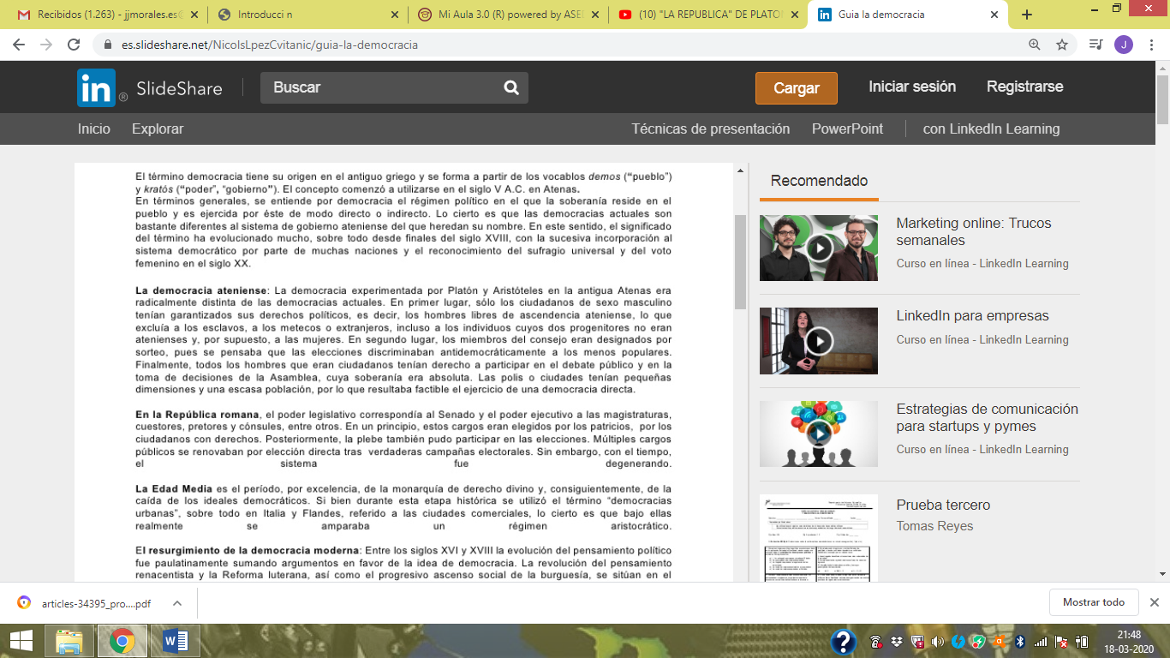

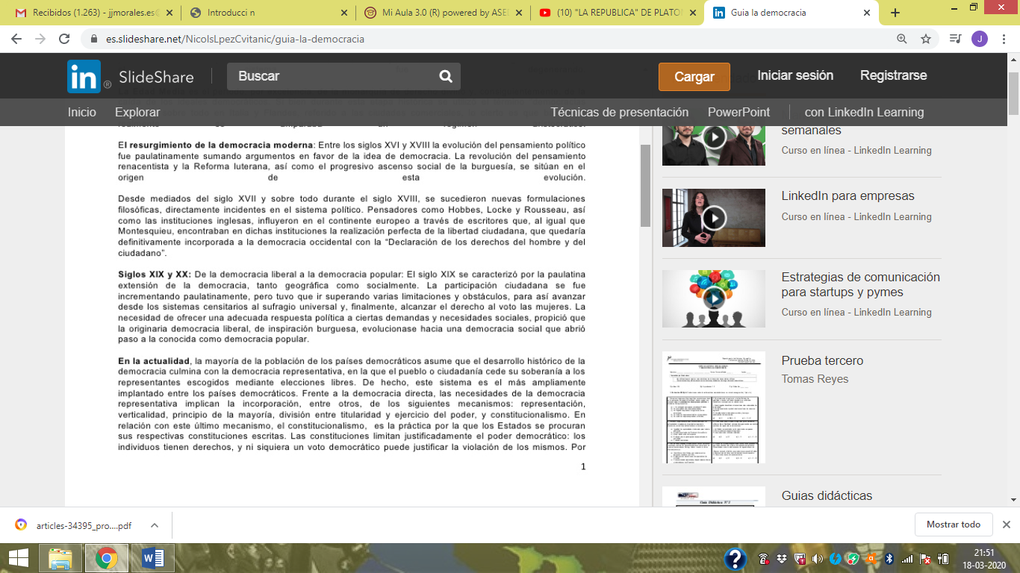

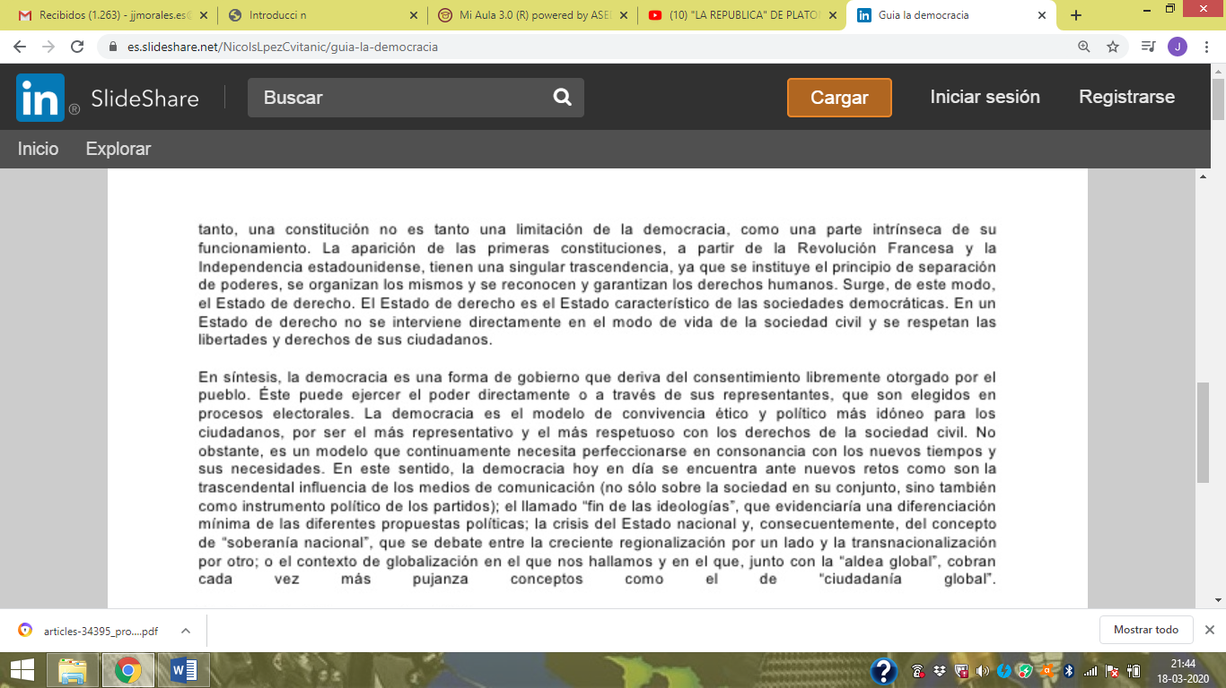

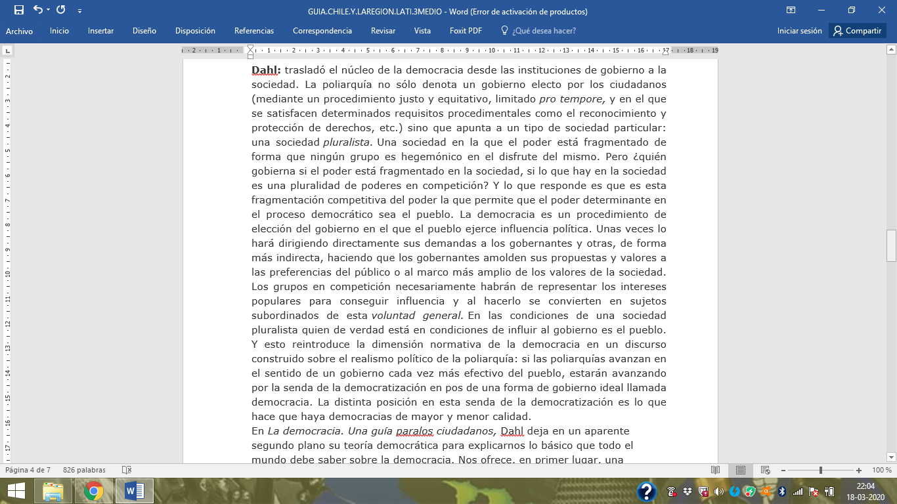

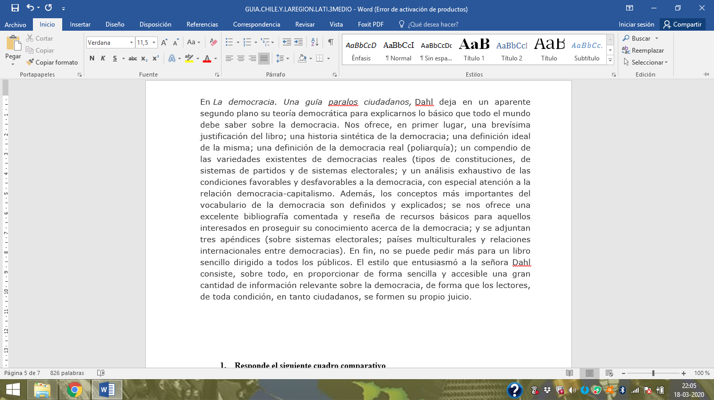

1. **Realiza un mapa conceptual considerando lo expuesto en los textos.**

|  |
| --- |
|  |

1. **Investiga sobre la visión de la democracia de los siguientes personajes:**
2. **Platón**

**_________________________________________________________________________________________________________________________________________________________________________________________________________________________________________________________________________________________________________________________________________________________________________________________________________________________________________________________________________________________________________________________________________________________________________________________________________________________________________________________________**

1. **Aristóteles**

**________________________________________________________________________________________________________________________________________________________________________________________________________________________________________________________________________________________________________________________________________________________________________________________________________________________________________________________________________________________________________________________________________________________________________________________________________________________________________________________________________**

1. **Rousseau**

**_________________________________________________________________________________________________________________________________________________________________________________________________________________________________________________________________________________________________________________________________________________________________________________________________________________________________________________________________________________________________________________________________________________________________________________________________________________________________________________________________________________________________________________________________________________________**

1. **Marx**

**________________________________________________________________________________________________________________________________________________________________________________________________________________________________________________________________________________________________________________________________________________________________________________________________________________________________________________________________________________________________________________________________________________________________________________________________________________________________________________________________________**

1. **Pericles**

**___________________________________________________________________________________________________________________________________________________________________________________________________________________________________________________________________________________________________________________________________________________________________________________________________________________________________________________________________________________________________________________________________________________________________________________________________________________________________________________________________________________________________________________________________________________________________________________________________________________________________________________________________________________________________________________________**

1. **John Lock**

**_________________________________________________________________________________________________________________________________________________________________________________________________________________________________________________________________________________________________________________________________________________________________________________________________________________________________________________________________________________________________________________________________________________________________________________________________________________________________________________________________________________________________________________________________________________________**

1. **A partir de la lectura del documento de Dahl, explica su visión sobre el concepto de democracia, luego investiga y expone brevemente sobre la poliarquía, democracia real y la relación democracia – capitalismo. (min.15 líneas)**

**__________________________________________________________________________________________________________________________________________________________________________________________________________________________________________________________________________________________________________________________________________________________________________________________________________________________________________________________________________________________________________________________________________________________________________________________________________________________________________________________________________________________________________________________________________________________________________________________________________________________________________________________________________________________________________________________________________________________________________________________________________________________________________________________________________________________________________________________________________________________________________________________________________________________________________________________________________________________________________________________________________________________________________________________________________________________________________________________________________________________________________________________________________________________________________________________________________________________________________________________________________________________________________________________________________________________________________________________________________________________________________________________________________________________________________________________________________________________________________________________________________________________________________________________________________________________________________________________________________________________________________________________**